New Winton Community Association

Trustees’ Annual Report 2024-2025

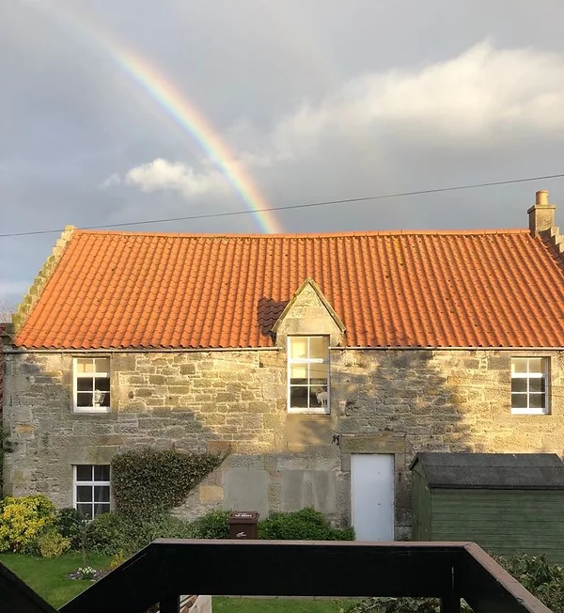

Contact information

New Winton Community Association

Scottish Charity Number: SC008775

FAO Sally Thomas, 9 New Winton Cottages, Near Tranent, East Lothian, EH33 2NH

07747 107730

newwintonhall@gmail.com
www.newwinton.co.uk
www.facebook.com/newwintonhall

Charity Trustees

1. Sally Thomas (Chair)
2. Janet Revez (Secretary)
3. Sophie Coats (Treasurer)

Objectives and activities

New Winton Community Association was established in 1980 in order to maintain the New Winton village hall and to manage its use in a way that will benefit the community, as per the original trust deed (see “Structure, governance and management”).

To this end, the committee meets regularly to organise hall maintenance, plan community events and discuss ongoing activities such as fundraising and hall bookings. Committee meetings, especially the AGM, also provide an opportunity for residents of New Winton and the surrounding area to voice questions and raise concerns about the village hall and its use, and provide a platform for further community collaboration and projects, such as maintenance of hanging baskets and the local play area.

Structure, governance and management

Governing document

The Trust Deed, established in 1980, gives the trustees indefinite tenure of New Winton village hall, under the following conditions (summarised for the purposes of this report):
- it is used as a community centre for the education and recreation of the residents of New Winton and the neighbourhood, with no political or religious affiliations;

- it is managed democratically by an unpaid and elected committee of residents of New Winton and the neighbourhood;

3) an annual general meeting is held each year to allow for election or re-election of committee members and the appointment of an auditor for annual accounts;

4) funds in the New Winton Community Association bank account should be spent on the maintenance of the building and resources for the education and recreation of residents.

Trustee recruitment and appointment

In the year 2024 -2025, Sally Thomas, Janet Revesz and Kate Hansen were elected as Chair, Secretary and Treasurer of the committee respectively. Other committee members are Hilary Dickson (bookings coordinator), Bridget Garvie (Facebook coordinator), Sophie Coates, Simon Poole, Amanda Pybis, Ian Suddaby and Chris Thomas.

Achievements and performance

In the 2024 - 2025 session the village hall has been well used for community events, and let commercially to a range of different users.

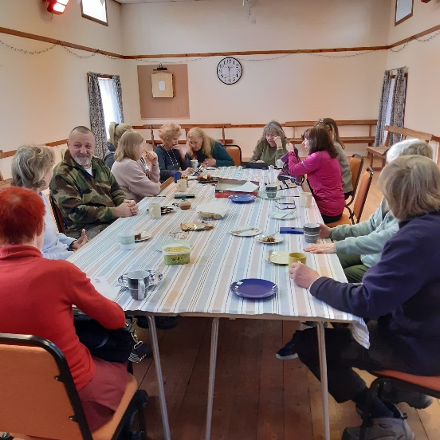
Community events organised directly by the committee have included the annual barbeque, coffee mornings, the weekly Cuppa and Chat social gathering, a very successful autumn craft fair and a pre-Christmas social evening. The autumn craft fair gave local producers and small businesses an opportunity to sell direct to the public. This was our most successful craft fair yet, and all the stall holders were delighted with the footfall and their level of sales. The weekly Cuppa and Chat and light exercise class has also continued, again with the benefit of grant funding from the Scottish Government Community Mental Health and Wellbeing Fund. Cuppa and chat has become a valued weekly opportunity for people from the local area to meet and socialise, with the added benefit of refreshments being provided.
Cuppa & Chat - 2025

We organised an evening event to enable as many people in the community as possible to learn how to use the new defibrillator which was installed during 2023/24. This was very well attended by local people.

The hall has also been well used by a range of other regular local groups and classes, such as yoga, baby and toddler group, sound baths, children’s parties and for private lets, such as for dancing.

All clubs, classes and social events are outlined at newwinton.co.uk/hall-clubs-classes/ and Village Events – New Winton Village Hall

All our events help to raise funds to support the running and maintenance of the hall. We have also gratefully received a grant from Pencaitland & District Community Council, and are identified as a “good cause” by the East Lothian Community Lottery.

The ongoing maintenance of the village hall is always on our agenda. An area of focus during the past year has been on ensuring that the hall remains fit for purpose and can continue as a vital community facility well into the future. We have successfully applied for planning consent from East Lothian Council to replace all the hall windows with new double-glazed units, and for the installation of solar panels on the village hall roof linked to battery storage. We hope that both these actions will enable us to reduce our future running costs, and ensure that as a community we contribute towards the path to net zero. Grant funding for both the windows and the solar installation is now being sought.

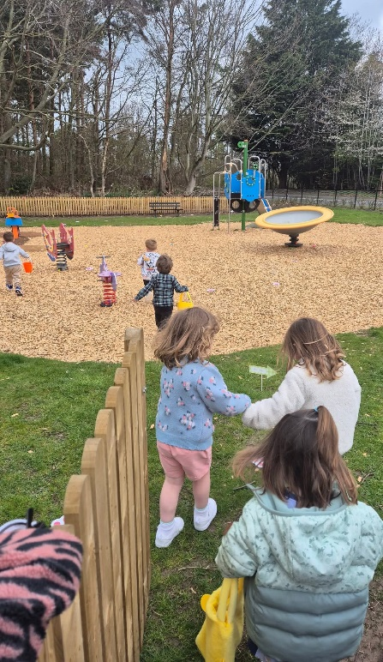
The Community Council grant was utilised to purchase storage shelving for the smaller “meeting room”. This has brought this room back into use and provides an additional meeting space at the village hall. The Community Council grant also enabled us to purchase materials for the repainting of the hall and corridors later in 2025. Prior to the repainting a considerable amount of refurbishment work was undertaken at the hall by volunteers to ensure that the building was ready for the repaint. Volunteers also gave their time to undertake repairs to the village hall following storm damage.

In the village more widely committee members have been actively involved in arranging for the planting of spring bulbs on the village green, organising hanging baskets donated by the community to brighten our village, and working with East Lothian Council to complete a full refurbishment of the local playpark, including new fencing and planning of new hedging to make the playpark secure and safe.

New Winton Nippers enjoying the refurbished playpark - 2025

Financial Review

Contribution from Christian Davis, FCCA

Statement of the charity’s policy on reserves

New Winton Community Association aims to keep 3 months’ operating costs in reserve in case of a sudden and dramatic loss of income; at the time of writing this is equal to £625. In addition to this, we aim to keep in reserve a fund for repairs. As a historic building in a conservation area, New Winton village hall requires maintenance of the building, for example the stonework, windows and roof, and the interior, for example the electrics and plumbing. To this end, the NWCA transfers £50 per month to our reserves to allow for sudden, potentially high repair costs.

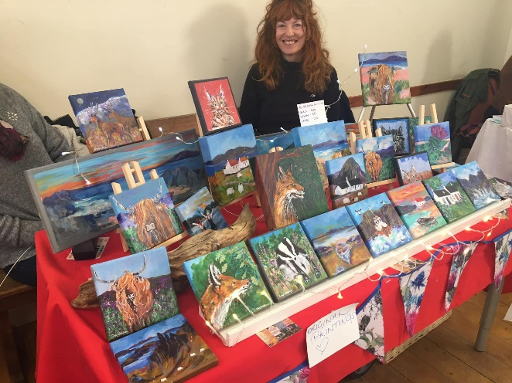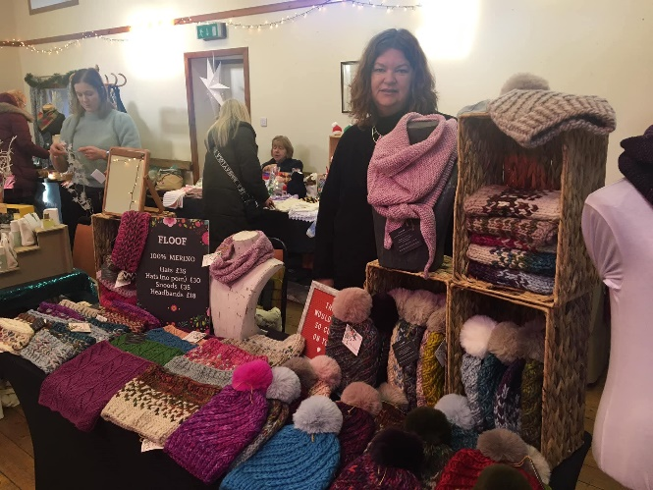

New Winton Craft Fair – Autumn 2024

Donated facilities and services

We have been fortunate to receive the services of Christian Davis FCCA, for free. As an impartial non-resident, Mr Davis compiles New Winton Community Association’s accounts on an annual basis, for submission to OSCR for analysis.

We also benefit from the numerous volunteers who donate their time and talents. While they are too numerous to mention individually, we do wish to extend our thanks to Bill Fulton who maintains our website for us, and to Al Coats who rebuilt our website earlier in the year when we needed to move to a new provider.

Future plans

Next year, we plan to continue to make the village hall available to local groups and users, and to organise local events for our community to enjoy. We are actively seeking grant funding to replace the windows in the village hall, and to install solar energy generation. Both actions should help us to keep our running costs down and ensure that we can continue to make the hall available at an affordable rate for local users and community events.

Declaration

Signed on behalf of the charity trustees:

Print name

Designation

Date

